1-1: Cold Backup – Bryan Mack

1. Determine the location of your datafiles, control files, and online redo log files.

SQL> select name from v$datafile;

NAME
----------------------------------------------------------------
C:\MSCD642\DBMS\APP\ADMIN\BK202\ORADATA\DISK1\SYSTEM01.DBF
C:\MSCD642\DBMS\APP\ADMIN\BK202\ORADATA\DISK1\UNDOTBS01.DBF
C:\MSCD642\DBMS\APP\ADMIN\BK202\ORADATA\DISK2\SYSAUX01.DBF
C:\MSCD642\DBMS\APP\ADMIN\BK202\ORADATA\DISK2\USERS01.DBF

SQL> select member from v$logfile;

MEMBER
----------------------------------------------------------------
C:\MSCD642\DBMS\APP\ADMIN\BK202\ORADATA\DISK5\REDO03.LOG
C:\MSCD642\DBMS\APP\ADMIN\BK202\ORADATA\DISK4\REDO02.LOG
C:\MSCD642\DBMS\APP\ADMIN\BK202\ORADATA\DISK3\REDO01.LOG

SQL> select name from v$controlfile;

NAME
----------------------------------------------------------------
C:\MSCD642\DBMS\APP\ADMIN\BK202\ORADATA\DISK3\CTRL1.CTL
C:\MSCD642\DBMS\APP\ADMIN\BK202\ORADATA\DISK4\CTRL2.CTL
C:\MSCD642\DBMS\APP\ADMIN\BK202\ORADATA\DISK5\CTRL3.CTL

2. Shutdown your database.

SQL> shutdown immediate;
Database closed.
Database dismounted.
ORACLE instance shut down.

3. Copy the files identified in step one to a backup folder

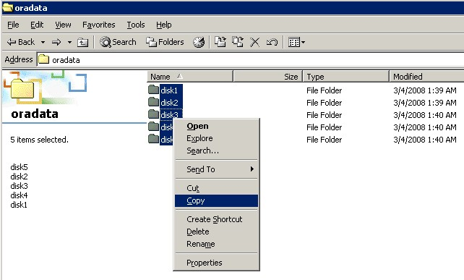

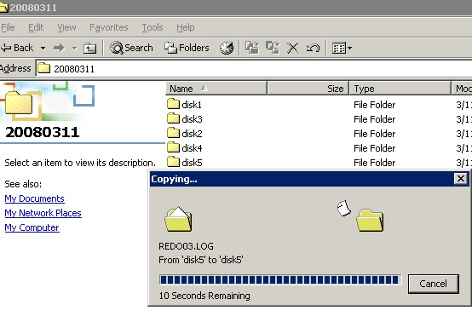

4. Startup your database.

SQL> startup
ORACLE instance started.

Total System Global Area 100663296 bytes
Fixed Size 1247492 bytes
Variable Size 58722044 bytes
Database Buffers 33554432 bytes
Redo Buffers 7139328 bytes
Database mounted.
Database opened.

